# **Sprint 3 Plan**

Risposta

Lino Le Van, Yiming Zeng, Matthew Macarewich, Nathan Lin, Trevor Gardner, Harrison Zhou

Revision #1, 2/16/2024

**Sprint 3 Completion Date: 2/27/2024**

## Goal

Our goals for Sprint 3 include creating a system that sorts relevant posts to the top of the user’s feed, create a system for commenting threading (the ability to comment on comments), add our AI responses, a basic FAQ page, and start brushing up and polishing UI/UX experience.

## Task List

* As an instructor, I want to see what questions students are most concerned about, [so that I can answer them and improve teaching quality]
* As a student, I want to have pages for basic questions [so that it filters out unnecessary posts]
* As a student, I want to see the most recent responses at the top and be able to search [so that I can stay up to date and not see old information]
* As a student I want to be able to comment on other students' posts and create a thread of some sort. [so I am able to help other students]

And from Sprint 2:

* As an instructor, I want to be able to invite students (and maybe TAs) to a space [so I am able to manage it all]

And from Sprint 4 (TA Recommendation):

* As a user, I want to work with a smooth and seamless UI so that my questions appear neatly organized and the site looks easy on the eyes.

## 

## Team Roles

Lino Le Van - Product Owner

Yiming Zeng - Product Developer

Matthew Macarewich - Scrum Master

Trevor Gardner - Product Developer

Harrison Zhou - Product Developer

Nathan Lin - Product Developer

## Initial Task Assignments

* Yiming: As an instructor, I want to see what questions students are most concerned about, [so that I can answer them and improve teaching quality]
* Nathan: As a student, I want to have pages for basic questions [so that it filters out unnecessary posts]
* Trevor: As a student, I want to see the most recent responses at the top and be able to search [so that I can stay up to date and not see old information]
* Lino & Matthew: As a student I want to be able to comment on other students' posts and create a thread of some sort. [so I am able to help other students]
* Lino & Harrison: As an instructor, I want to be able to invite students (and maybe TAs) to a space [so I am able to manage it all]
* Matthew: As a user, I want to work with a smooth and seamless UI so that my questions appear neatly organized and the site looks easy on the eyes.

## Initial Burnup Chart

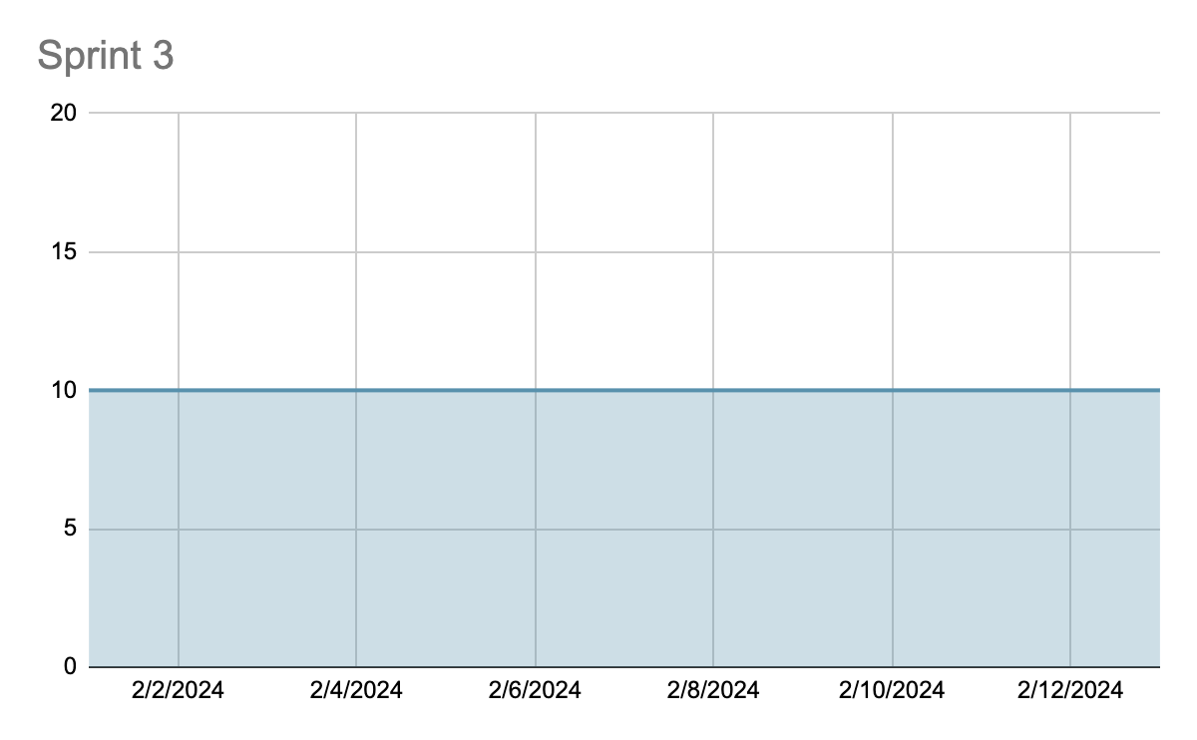

## Initial Scrum Board

<https://trello.com/b/jMbIVKPE/risposta>

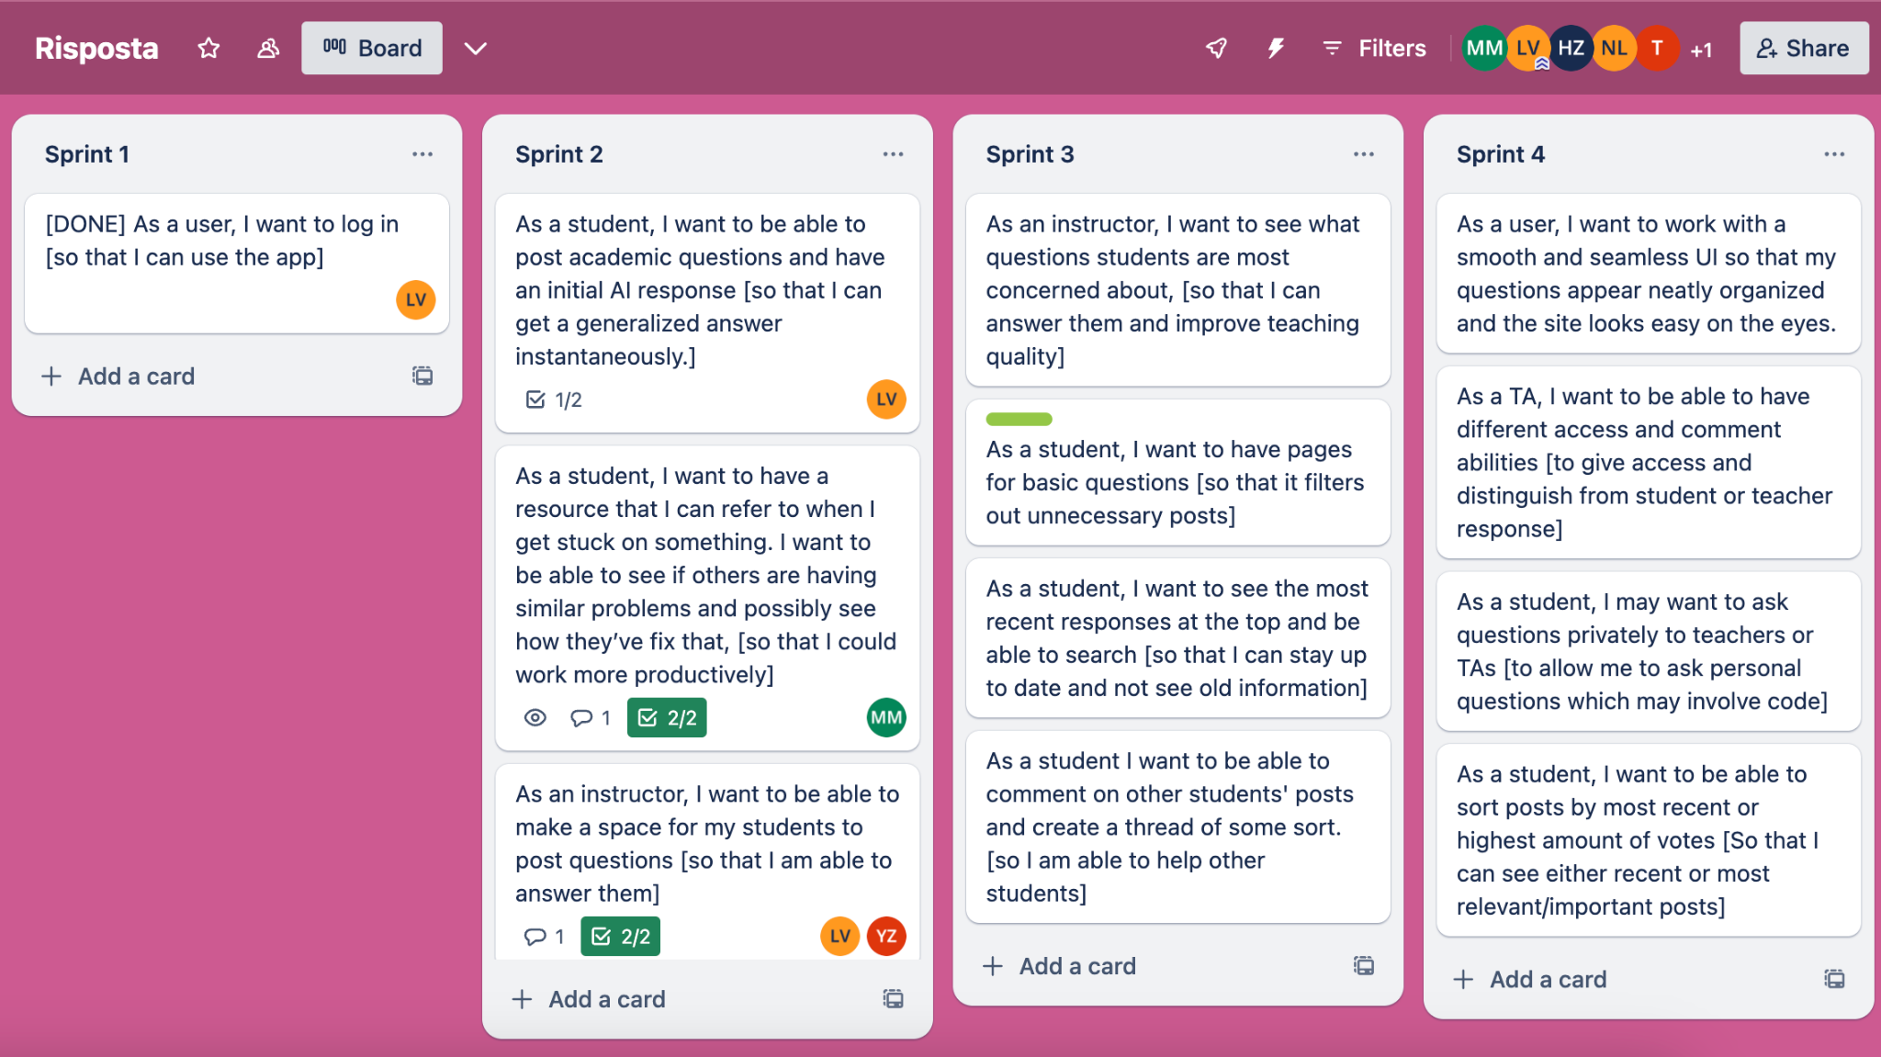

## Scrum Times

We plan to have our scrum meetings M/W/F at 9pm. Our TA meetings will be held on Thursday from 9:30-10:15.